Licensing Overview

Tableau Server term licenses are available with two different license metrics: User-Based and Core-Based. Term licenses, also known as subscription licenses, allow you to use and update Tableau Server for a specified period of time.

## User-Based licenses

Tableau offers User-Based term licenses that grant a range of capabilities at various price points. Multiple types of User-Based term licenses are available: Viewer, Explorer and Creator. The following capabilities are available to users with these licenses:

* Viewer licenses let users view and interact with workbooks in Tableau Server or Tableau Online. Viewer licenses also let users access Tableau Mobile, add comments to workbooks, download .png and .pdf versions of workbooks, download workbook summary data, create subscriptions for themselves, and receive data-driven alerts.
* Explorer licenses are equivalent to the User-Based term licenses available in previous Tableau Server and Tableau Online releases, and include the capabilities provided with Viewer licenses. Depending on a user’s site role, a user with this license will have access to workbook authoring capabilities using a web browser, as well as a full set of collaboration features.
* Creator licenses grant a wide range of capabilities when using Tableau Server and Tableau Online, and also grant use of Tableau Desktop and Tableau Prep. Depending on a user’s site role, a user with a Creator license might have all of the capabilities available under the Explorer license, as well as the following capabilities when using Tableau Server and Tableau Online:
  + Create and publish new workbooks from a new data source.
  + Edit embedded data sources in the Data pane.
  + Create and publish new data connections.
  + Create new workbooks using Dashboard Starters (Tableau Online only).

Server administrators can view the license and product key information for Tableau Server.

## Viewing licenses from the Tableau Server web UI

How you navigate to the Licenses page in Tableau Server depends on whether you have a single site, or multiple sites.

* On a server with a single site, click **Settings** and **Licenses**:
* On a multi-site server, click **Manage all sites** on the site menu, **Settings**, and **Licenses**:

**Note:**  The **Manage all sites**option only displays when you are signed in as a server administrator.

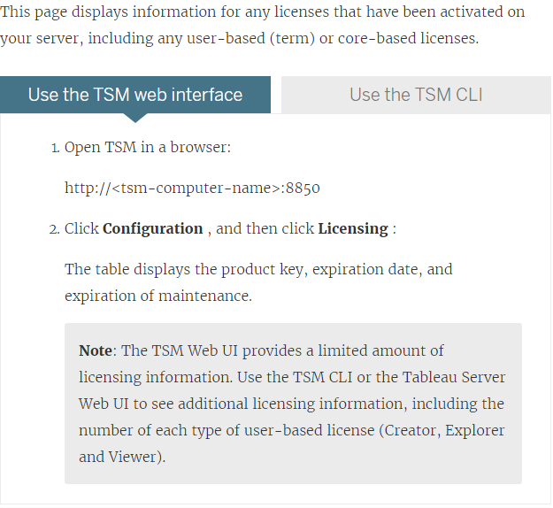

### Licenses are not immediately available

When you add a role-based license to Tableau Server, those licenses become available to all users when you restart Tableau Server. If you don't restart Tableau Server, role-based licenses become available to all users within 24 hours.

### Server Administrator site role is unchanged when using a Creator license

Server Administrators gain Creator capabilities if Creator licenses are available in Tableau Server, with no change to their site role name. All other Tableau Server and Tableau Online users gain Creator licenses only if assigned to a site role that includes Creator in its name.

### A user or administrator is unlicensed due to license expiration

To avoid having users unexpectedly become unlicensed or move to another site role, you should always do one of the following before the license that they are currently using expires:

* Renew and activate a replacement license. If a user occupies a Creator, Explorer or viewer license and their license expires, they will use another license of the same type, if available.
* Change the site role of those users to allow the use of a license that is not due to expire.

The reassignment of users to new licenses is governed by the following logic:

* When a Server Administrator user occupies a Creator license and their license expires (with no replacement licenses available), they are reassigned to an Explorer license if any Explorer licenses are available. This license reassignment occurs in order of most recent login. Server Administrators displace other users who might be currently using an Explorer license. If no Creator or Explorer licenses are available a Server Administrator becomes unlicensed.
* When a non-Server Administrator user occupies a Creator license and their license expires (with no replacement licenses available), they become unlicensed. To avoid having these users become unlicensed, change their site role prior to license expiration. This is especially important for users in the Site Administrator Creator site role, who must move to the Site Administrator Explorer site role before their Creatorlicense expires to avoid losing Site Administrator capabilities.
* When a non-Server Administrator user occupies an Explorer or Viewerlicense and their license expires (with no replacement licenses available), they are upgraded to a higher license type, if licenses of that type are available. Specifically, the following occurs when a license expires:
  + Users who occupy an Explorer license will move to a Creator license, if available (with no change to site role).
  + Users who occupy a Viewer license will move to an Explorer license, if available. If no Explorer licenses are available, these users will move to a Creator license, if available (with no change to site role).
  + If no licenses are available at the higher license types, those users are moved to Unlicensed.

Users are reassigned to a new license as described above in order of most recent login, with lower license types reassigned first (first Viewer, then Explorer, and then Creator).

For example: Two users with a Viewer license, a user with the Creator license, and two Server Administrators with a Creator license all have their licenses expire. Four unexpired Explorer licenses are available for these users. In this situation, the following occurs in the order shown below:

1. The user with a Viewer license who logged in most recently is reassigned to an Explorer license.
2. The second user with a Viewer license is reassigned to an Explorer license.
3. The Server Administrator user with a Creator license who logged in most recently is reassigned to an Explorer license, and then the second Server Administrator with a Creator license is reassigned to the remaining Explorer license.
4. The user with the Creator license becomes unlicensed.

### A user with a Viewer license cannot open Tableau Server or Tableau Online workbooks from Tableau Desktop

A user with a Viewer license who also has a separate Tableau Desktop license will be unable to open workbooks on Tableau Server or Tableau Online using Tableau Desktop. To open workbooks such using Tableau Desktop, that user will need an Explorer or Creator license on Tableau Server or Tableau Online.